BFS (Using Queue)  from queue import Queue  graph={'A':['B','D','E','F'],'D':['A'],  'B':['A','F','C'],'F':['B'],'C':['B'],'E':['A']}  print("given graph is:")  print(graph)  def BFS(input,source):  Q=Queue()  visited_vertices=list()  Q.put(source)  visited_vertices.append(source)  while not Q.empty():  vertx=Q.get()  print(vertx,end=" ")  for u in input[vertx]:  if u not in visited_vertices:  Q.put(u)  visited_vertices.append(u)  print("BFS traversal of graph with source A is:")  BFS(graph,"A")  OUTPUT:  given graph is:  {'A': ['B', 'D', 'E', 'F'], 'D': ['A'], 'B': ['A', 'F', 'C'], 'F': ['B'], 'C': ['B'], 'E': ['A']}  BFS traversal of graph with source A is:  A B D E F C  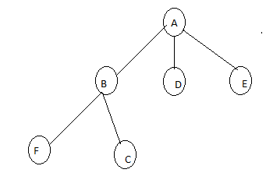 | DFS(Using Stack)  graph={'A':['B','D','E','F'],'D':['A'],  'B':['A','F','C'],'F':['B'],'C':['B'],'E':['A']}  print("given graph is:")  print(graph)  def DFS(input,source):  stack=list()  visited_vertices=list()  stack.append(source)  visited_vertices.append(source)  while stack:  vertx=stack.pop()  print(vertx,end=" ")  for u in input[vertx]:  if u not in visited_vertices:  stack.append(u)  visited_vertices.append(u)  print("DFS traversal of graph with source A is:")  DFS(graph,"A")  OUTPUT:  given graph is:  {'A': ['B', 'D', 'E', 'F'], 'D': ['A'], 'B': ['A', 'F', 'C'], 'F': ['B'], 'C': ['B'], 'E': ['A']}  DFS traversal of graph with source A is:  A F E D B C  

